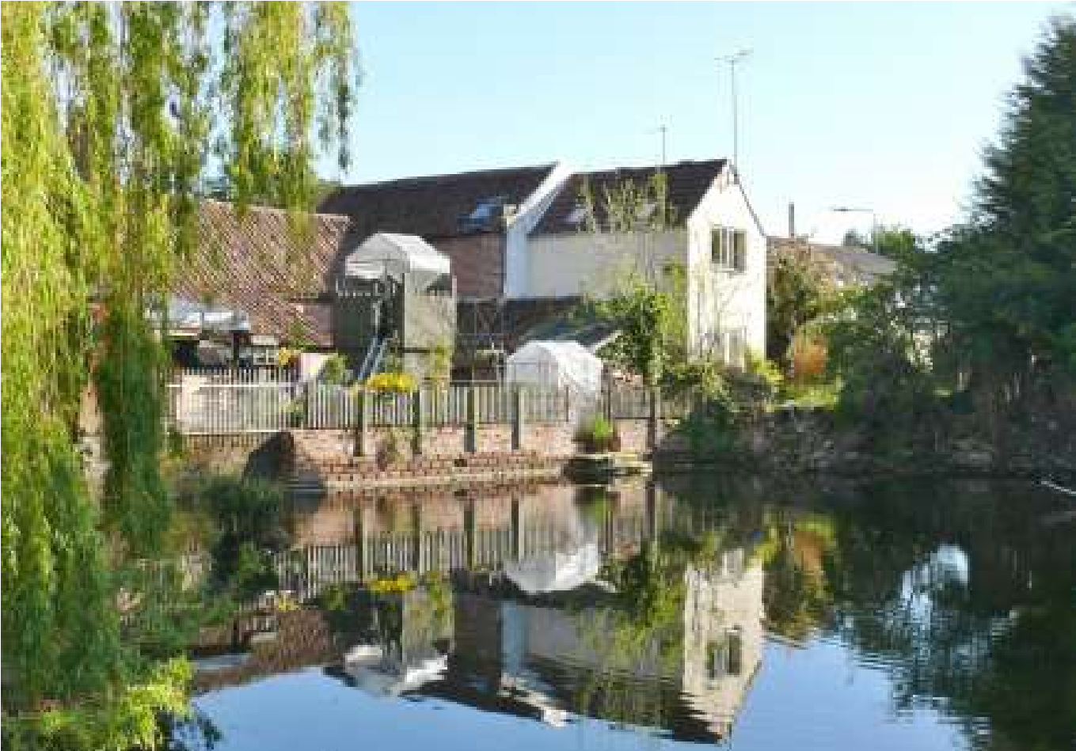

The Newsletter for Middleton on the Wolds

Issue No 26

MAY

2021

NEXT COPY DATE
14th May

Please send in your contributions to middletonflyer@yahoo.com by the end of the copy day. If I don’t acknowledge them please get in touch to make sure they have arrived.
Another front page photo from my archives, this time from May 2013. It would be nice to have some of your pictures so please send them in.
It is very pleasing to see that so many villagers are getting in touch with Barbara to share their sightings of wildlife, keep them coming.
Thank you to Pat for sending me the recipe for Chocolate and Pecan Fingers. She tells me they are delicious so I can’t wait to make some.
Lyn
4 The Paddocks 219500
ADVERTISING COSTS for the Messenger
Rates Month Year

Whole Page £25 £150

1/2 Page £15 £100

1/3 Page £10 £60
Full colour - Print run 500 copies
Contact: Tina 01377 217242, middletonflyer@yahoo.com

editorial
We are moving through the levels of lockdown relaxation now and, other than finally being able to get out of the house, some of our neighbours have been putting a lot of work doing things for the village.
Well done to Chris Atkin for his work restoring the
bench outside the church. It made me think about what some people in the village have done, and are doing, not for personal gain but simply to benefit the community. As well as the work done by Andrew Naylor on the embankment a good number of people are putting a lot of effort into getting the gala up and running. But apart from repairing outdoor furniture, planting trees and organising sporting events what else can you do?
Just take a look at the back cover of this newsletter. Apart from the sports clubs there are organisations and amenities that don’t just run themselves and which are all looking for committee members, from the Parish Council to the Reading Rooms and the Village Hall. I have heard it suggested that joining such committees is ‘not for the likes of us’ or that ‘your face doesn’t fit’. Believe me that is not the case. You don’t need any special qualifications don’t need to be a certain age and if my ‘face fits’ anyone’s can! The only thing you need is to want to help. So give one of those contacts a call and see what you can do for Middleton on the Wolds.
I can’t finish without mentioning the sad passing of Prince Philip, the Duke of Edinburgh. One of the last of his generation in public service he certainly wasn’t everybody’s cup of tea, but no-one can deny his hard work and complete commitment to supporting the Queen. Whether you liked him or not it is hard to deny the, mostly, positive effect he had on the nation.
Stay safe.
Mike
If you have any ideas, comments or complaints (especially complaints) you want to share then send an email to middletonflyer@yahoo.com.
Remember, we can’t respond unless we receive your message.

QUIZ PAGE
- Events are said to be coming thick and ?
At the start of a snooker frame what ball is placed between yellow
- and green?
What 2013 film stars Maggie Smith as Jean and new arrival at home
- for retired musicians? .....
- What Andrew Lloyd Webber musical is based on poems by TS Eliot?
- In what decade was the first Guinness Book of Records released in the UK?
- Which Finnish company launched the Excel smart phone in 2014?
- Which motorway connects London and Bristol?
- A popular myth is that so called dog years equate to how many human years?
- Florence is the capital of what Italian region?
- Which labour prime minister became the Viscount of Prestwood?
Quiz set by Rowland Wooldridge
All answers on
page 17

CRYPTIC

TOWNS & CITIES

NAME THE
BRAND

Parish council

POT HOLES
Following complaints from residents on South Street about the number of dangerous pot holes on the street East Riding Yorkshire Council was contacted and as a result most of these have now been filled and made good. Whilst the reporting was done by a Parish Councillor any member of the public can report them direct to ERYC on line. Sending a photograph of the pot hole helps identify the area of concern. This is easy to do and supports your report.
To report a pot hole or other issue with a road, footpath or kerb in our village visit www.eastriding.gov.uk-roads-pavements-and-traffic and follow the link under “Featured Items”.
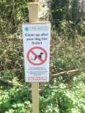

DOG FOULING UPDATE
Sadly dog fouling continues to be a big issue in our village. Despite recent articles appearing in the Messenger about both the facts and dangers of this anti social behaviour and its real risk to all our health, particularly that of children, it continues on a daily basis. Who are you and why do you do this?
Two residents living on South Street recently reported dog fouling directly outside of their properties with one resident having 2 bags of dog poo being deposited on his front lawn. There has also been recent incidents of dog poo being found on the Recreation Field where both young and not so young exercise and play.
There really is no excuse. There are 10 litter bins around the village where bagged dog poo can be deposited and following these Incidents the Parish Council has increased the number of warning signs and have refreshed some of the existing ones. The Council will continue to consider other measures that may help reduce the problem but it needs all of us in the village to be alert and where it can be done safely to act by reporting it to either a dog warden/ local Authority. This can be done as an anonymous request. East Riding Yorkshire Council have expressed a willingness to prosecute offenders and issue a fixed penalty fine of £75. (for the website- East Riding.gov.uk - Environment - Dog control and Ownership and follow the link) Sad as it is, it may be the only way to effectively tackle the issue.
So, whoever you are, you have been warned.
Please respect YOUR village and do the right thing by disposing of your dogs waste properly and in the bins provided. Thank you.
Nick Jones
Middleton on the Wolds Parish Council
PRESS RELEASE
We are excited to announce that funding has been approved for our project for the play equipment situated at the Recreation Ground in the village.
Children big and small are set to get some exciting new equipment, to play, exercise and have fun, thanks to a grant of £63,570.00 from FCC Communities Foundation, plus £6857.50 from ERYC Commuted sums.
The money will be used to remove the old wooden equipment and install a bespoke multi play unit, aerial runway, nest swing, roundabout, 5 arm rotator with kite surfing handle and seat, rope ladder with 2 button seats, a 2-seat cradle swing and 2 seat junior swings, and an animal toddler springer, and we are eager to start work with our approved contractor Team Sport and Play.
The new equipment will be installed on the area of the old site at the Recreation Ground at the top end of Front Street, Middleton on the Wolds, and work is due to commence 7th June 2021.
Middleton on the Wolds Parish Council believe that the facility will make a huge difference to families in the area as well as attracting visitors.
The project will provide a real boost to the people of Middleton on the Wolds, and give great support to other facilities on the Recreation Ground site. It is fantastic that the FCC Communities Foundation has awarded us this money and we are really looking forward to our project taking shape over the next 2-3 months.
FCC Communities Foundation is a not-for-profit business that awards grants for community projects through the Landfill Communities Fund.
Media information
For further press information please contact Sandra Morrison on 01262 470496 pc@middletononthewolds.co.uk or Cllr Tina Walker 01377 217242 .
Notes to editors:

FCC Communities Foundation is a not-for-profit business that awards grants for community, conservation and heritage projects from funds donated by FCC Environment through the
Landfill Communities Fund and Scottish Landfill
Communities Fund. Since 1998, FCC Communities Foundation has granted over £200m to more than 7,000 projects which benefit people living within 10 miles of a FCC Environment landfill site. For more information please visit www.fcccommunitiesfoundation.org.uk social infrastructure of the communities around landfill sites. www.fccenvironment.co.uk

Posters of the equipment can be seen in the Post Office and village notice boards.

Tina Walker

Middleton book group
The two books this month were wildly contrasting in every way (apart from both being books):
"Surfacing" by Margaret Atwood, and "Wyrd Sisters" by Terry Pratchet.
Margaret Atwood writes a wide variety of novels, some of her best-known ones being speculative fiction such as "The Handmaid's Tale", but "Surfacing", while a work of fiction, draws on her experience as a child being largely brought up in the backwoods of Northern Quebec where her father pursued his forest entomology studies. This book however is a story of two couples searching for the narrator's father who has disappeared from the family cabin. She becomes overwhelmed by her childhood memories and gradually becomes detached from reality - and her fiancé - descending into the realms of wildness and madness. It does however end on a slightly more optimistic note when her fiancé returns to look for her, although our last view of her shows her watching the search from a hidden vantage point but considering re-emerging from the forest.
We all found this quite hard going, the characters all being rather unsympathetic, but I found that the quality of Atwood's writing carried me along, and several of us agreed that her description of the main (unnamed) character's mental disintegration was very compelling.
To provide some light relief we turned to my second choice, "Wyrd Sisters" one of my favourite books. Unfortunately I was the only fan - some people simply do not like books set in strange and magical places, and some found Pratchet's jokey style of writing annoying (and there was some confusion with people thinking that the discworld series are children's books - or for 'young adults' ).
Oh well, we all agreed that the whole point of a book group is to try books that we wouldn't necessarily choose ourselves!

Barbara

Next books for discussion:
“To Everything a Season” by Lauraine Snelling “The Thursday Club” by Richard Osman

To find out more about the Book Group please contact Lyn on 219500 or lyndennis456@gmail.com

LOCAL HISTORY
SCHOOL DAYS – A NEW
BUILDING
The new school in Station
Road, provided at a cost of
£30,000, was occupied from the 28th April 1968 with an official opening ceremony on the 1st
November by the Right
Honourable Richard Wood M.P.
for the area. Also in attendance was the Rector of Middleton with Dalton the Reverend C Hume who as Chairman of the school governors also presided while the Bishop of Hull, The Right Reverend H L Higgs, conducted a short service of dedication.
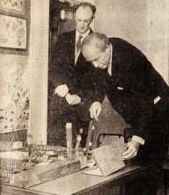
The teaching staff on opening day in April were the headmaster Mr J A W Goodrick; Mr C B Rose, Mrs D Woodliffe and Miss E M Walker. Other personnel consisted of Mrs E Hardwick, cook; Mrs C Lewis, assistant; and Mrs D Jenkins, supervisor. The caretaker was Mrs R Mizon; school crossing patrol Mrs M Colley with Mrs C Walker as the school secretary. At the opening there were 99 pupils on roll and in the early days the new school had frequent visitors who were anxious to see an open plan teaching arrangement at work. In November 1970 there
John Goodrick, Headmaster

was the first meeting of the Parent Teachers Association.
In July 1972 John Goodrick left to take up an appointment as headmaster of the much larger Willerby Carr Lane school. He led a busy life as he was also Chairman of the Driffield Council of Churches, Middleton Youth Club and Playing Fields Committee as well as being a churchwarden, a member of the Parochial Church Council, the Deanery Synod and the Village Hall Committee. On leaving he presented a shield to the school as a trophy for future sports days. He died tragically in 1977 leaving a widow, Stella, who was a teacher at Middleton School and two young daughters.
The new headmaster Mr P G Sykes, a Howden man who had been Head of Weaverthorpe Church of England School for the past 3 years, took over in January 1973 and continued until his retirement in 1990. He was succeeded by Mrs Ann Adamson followed by Mrs Christine Bennison and in 2012 by Mr Woodhouse.
From the 1980’s the school had to cope with the demands of new technology, constant staff training and management of budgets whilst dealing with the ever changing requirements placed on education by the central government which was itself subject to fluctuations in policy: it was often said that education became a “political football”.
In common with similar village schools a fall in pupil numbers could have threatened closure but its federation with other educational establishments in 2007 helped to strengthen its position and on reopening after the summer holidays in 2011 the staff and children returned to a much extended building with high tech facilities which would have amazed the staff and “scholars” of the 1870s. The present Executive Head Teacher, Mrs Elizabeth Harros presides over a federation of three Church of England Primary Schools: Middleton on the Wolds, Beswick and Watton and Bishop Wilton whose aim is encapsulated in the motto “Love Laugh Live Learn”.
At the time of writing this article the school and village are slowly emerging from the national Covid crisis with the consequent threat to children’s education and their future prospects.
Finally the author would like to place on record his gratitude to Mrs Christine Bennison for the loan of the school records which are now deposited in the Treasure House in Beverley which have proved invaluable and Stella Goodrick for the press photograph of John.
Geoff Wisher

Local Birds & wildlife
I have just noticed that at the end of last month’s item I had a paragraph starting “Lastly…” followed by one starting “Finally…” Not a good writing style, but the reason was that the badger trotted into view just after the deadline for the March Messenger and I overlooked it until I had worked my way to the end of April. This month again there was a flurry of sightings just after the April issue deadline, so I am starting with an email from Jim received on 18th March:
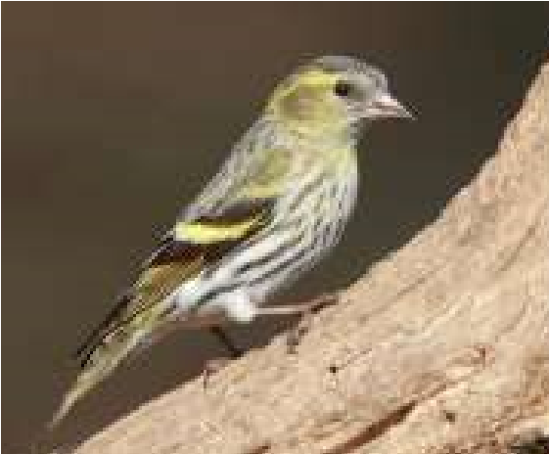
“Saw a bird very similar to this this morning down the old railway line past the council depot” forwarding the picture of the siskin. Lovely little birds and I have seen them in the garden (looking back at the records, the last time was in 2012, so not a regular visitor).
Then at the end of March Pat reported “We’ve had a French partridge visit, and the other day a hen pheasant.” While at the same time we had a pair of partridges visiting our garden –
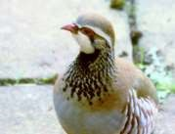
and a hen pheasant flew up on my kitchen window ledge, which made me jump! The French or red-legged partridge was apparently introduced into the country by Charles II because overhunting of the native grey partridge left him short of quarry. Luckily, unlike red and grey squirrels, the red-legged partridge is an inoffensive bird which doesn’t upset the native birds – but intensive agriculture methods have seen the greys’ numbers plummet anyway.
Johanne also got in touch then and emailed: “My son and I were thrilled to see a red deer in the woods just past the Produce Shack up Goodmanham Road yesterday on our walk. It was a female. We used to regularly see roe deer behind our house on Station Road but haven’t seen any since the trees were felled a couple of years ago. It’s the first time we have ever seen a red deer in the village.”
Then we are into April, with Pat again helping me with my appeal for wagtail sightings: “Just thought you would like to know I’m just watching a pair of pied wagtails in the mirror while I’m drying my hair – what a treat! We used to see lots of them on the school roof years ago and actually had a yellow one on the deck. Yesterday I spotted a sparrow hawk just sitting near the pond. They usually just fly straight through chasing the little birds.” The wagtail news was particularly welcome. Incidentally, the grey wagtail also has a lot of yellow on it in summer, but does have a grey back.
Barry and Joanna are having exciting times in their garden: “Now that Spring has arrived more birds are coming into the garden. We haven't seen any migrants yet - they have been arriving down South so it won't be long before they get here.
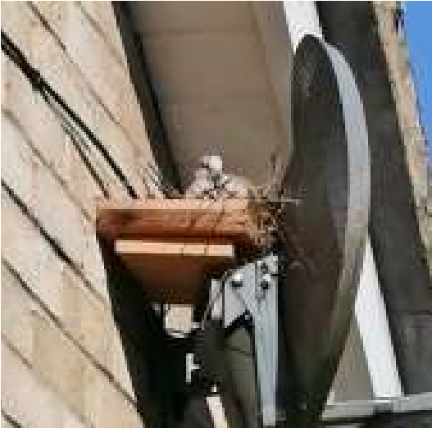
Here is a picture of the first nest in our garden this year the Doves normally nest in our Cherry trees along with the Pigeons but this year the Doves decided to try and make a nest on the bracket that holds tv dish on the wall but as fast as they tried to the twigs fell to the ground because the bracket is barely 2" wide so we took pity on them and Barry got some wood and made a platform for them now they are sitting. Still seeing plenty of Buzzards and kites when we look out of the window and walking round the village. Sparrowhawks and Woodpeckers are
coming back into the garden more often now. Stock Dove still comes to our feeders. Sadly not many Marsh tits at the moment. “
Thanks to everyone who got in touch; it is lovely hearing from so many people! Usual contacts for anyone who would like to join in with the June ‘Birds and Wildlife’: lavenderbarbara97@gmail.com or text 0777 192 7868. If you get this in by 12th you can be sure it will be included.
Finally (really!) Ian has been taking pity on the birds after a particularly frosty night: “Found an end piece of fruit cake – a bit stale and 2 to3 inches cube. I thought the birds might like it and wedged it into the branches of a bush in the garden. By the time I was back indoors it was on the lawn and a song thrush had taken possession and was defending it fiercely against all comers including birds twice its size; blackbirds, collared doves and wood pigeons. It was quite a stand-off.
“A bit later and the thrush must have had enough and a couple of blackbirds were in possession. Then something strange happened. They were really keen and would peck at it but then recoil two to three feet as if hit with a bolt of electricity. It would not put them off and they continued with this peck – leap backwards as if struck with lightning behaviour for as long as I watched (Alright until Pointless came on the telly).
“Anyway it was all gone a bit later. It makes you think that if fruit cake made people leap six to eight times their body length each time they touched it – it could be sold as health food.”
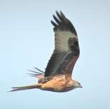
A last minute email from Karen: “I learnt a new word this month, after observing some playground like behaviour from a red kite and a crowd of crows! What I saw was the red kite emerging from some trees near the cemetery and chasing a crow across the road and towards the church. It seemed to flying right at the crow, knocking it off its course. Unfortunately for the kite, it went a bit too far and ended up near the rookery at the top of the village. I then watched, amused, as it was followed back by a group of crows evidently standing up for their comrade and chasing it away. The kite made a hasty retreat! I since learnt that Red Kites are kleptoparasites, stealing food from other birds. So we have our very own pirates in the bird world, right here in Middleton.”
I hasten to add that the Red Kites are definitely flying a home flag over the village, with several sightings up South Street and beyond.
Barbara

CHOCOLATE & PECAN FINGERS
recipe

90g dark chocolate
125g butter
2 teaspoons instant coffee grains
2 eggs
180g caster sugar
1/2 teaspoon vanilla
120g plain flour
90g chopped pecan nuts
Makes 15 Fingers
Icing sugar for dusting Oven: 1800C/ gas 4

- Melt chocolate and butter over hot water, stir in coffee and allow to cool slightly
- Whisk eggs in a medium bowl until foamy, add sugar and vanilla
- Fold chocolate mix into eggs and stir in flour and pecans until just blended
- Spoon mix into a 20cm/8in cake tin
- Bake for 25 minutes until cake springs back when touched
- Cool in tin, dust with sifted icing sugar and cut into fingers
Recipe sent in by Pat Pottage

Middleton produce show
Hope you have all kept well and have been busy clicking with your cameras/phones for our special booklet. This will be your booklet of your photos, which we hope will capture a snap shot of village life, celebrations, creations, achievements , produce and events during this last difficult year. A copy of which will be delivered to every household.

We are NOW ready for you to send your photos in. Please note that nothing will be judged this year

The categories are as follows:-
Events in this last year
Something that you have or that has been created/achieved this year
Your hero/heroes
A display of vegetables/fruit from your garden
A vase of flowers from your garden
A flower arrangement entitled “a tribute to keyworkers”
Something baked for an afternoon tea
A display of handicrafts you have made
Your favourite photograph
Childs picture/painting/collage (accompanied by name and age)
A lockdown/pandemic poem

A maximum of 5 photos per category may be submitted and they must be submitted no later than JULY 1st 2021
Send your photos including a brief description and your name and contact details to Cindy by email to :- cmpgep@yahoo.co.uk
Photos should be in format JPEG,PNG or HEIC/HEIF,
Under 25MB in size
Not more than 100 million total pixels (width x height)

Don’t worry if this doesn’t make sense just send your phone/camera picture with an accompanying message with your details. If getting a
photo/emailing is difficult please contact Cindy on 01377 217865 and she will arrange to photograph your items for you.
We are also hoping to create a banner or large A1 posters for displaying and celebrating all your efforts in the village
Please note that any handicraft etc. that you have made since the last produce show in 2019 may be entered in next years more traditional produce show when we shall again, hopefully be able to welcome our judges again.
The committee reserves the right to manage the number/size of entries in each category
Chris Brent, Show Chair

St Andrew’S church
Sunday 2nd. May. Morning Prayers at 10.30.a.m.
Sunday 9th. May. Holy Communion at 10.30.a.m. Rev. Jane Anderson.
Sunday 16th. May. Holy Communion at 10.30.a.m. Rev`d Canon Kate Goulder Sunday 23rd. May. Holy Communion at 10.30.a.m. Rev`d Ruth Newton.
Sunday 30th. May. Benefice Service. Time and venue TBA.
Quiz answers

Bath
1

2
Margam

3
Dover

4
Winchester

5
Tenby

6
Edinburgh

7
Doncaster

8
York

9
Saundersfoot

10
Exeter

1

Fast

2

Brown

3

Quartet

4

Cats

5

's
1950

6

Nokia

7

M4

8

Ten

9

Tuscany

10

Clement Attlee

A note from your vicar

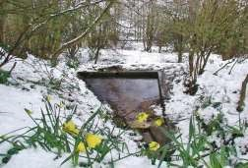
MAY - HOLY WELLS
A few weeks ago I had a lovely walk along the Hudson Way at Market Weighton and we came upon St
Helen’s Well, a surprising find among the trees. Not knowing a great deal about Holy Wells, I thought I would find out more. Apparently, there are 1000’s in the British Isles. They are mostly natural springs and many are now over grown and long forgotten,
but some are still centres of pilgrimage as they once were, long ago in pagan times. (I do not use the term ‘pagan’ in a derogatory way but to refer to those who saw or see the divine, god and/or goddess, in nature)
People visited these Wells hoping for healing or seeking divination and would often drink or bathe in its waters, indeed many Wells have been found to contain certain minerals which may aid well-ness. The shrine would be dedicated to the power of the living water which emerged from it. These places were popular focal points for worship until the Roman Church came along and tried to stamp out this practice, however, their popularity was such that the church could not dissuade people from visiting them so instead they were ‘converted’ into Christian shrines and dedicated to saints – popular saints were Helen (St
Helena’s Day falls on 21st May, she is the Protector of the Holy Places) and also ‘Ladywell’, once dedicated to pagan goddesses and their priestesses, but
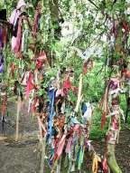
rededicated to the Virgin Mary – one can be found in Kilnwick.
It was usual to leave a token – often clothing would be hung on a nearby bush or tree – St Helen’s Well on Hudson Way is embellished with ribbons. These were left in the hope that the healing power of the well would work upon its owner. An offering of a pin was also often made which led to many wells being called ‘Pin Wells’.
Many churches were built near Pagan sacred wells, indeed the early Celtic Church used them for baptism, until the Roman Church intervened and replaced these with fonts inside the church.
So why am I writing about Holy Wells for May, well
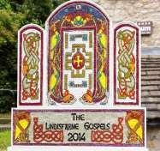
(sorry!) it was traditional to visit the wells at special times of the year and May was one of those times. Today, in villages in the Peak District, (and in Penistone – South Yorkshire) local wells are still honoured by being decorated at the annual Well-Dressing ceremony. To dress the well a wooden frame is made, soaked in the local river for a few days, then filled with wet clay into which flowers, moss, berries etc are pressed to form a picture – ranging from biblical to historical and popular images. A beautiful and creative way of connecting us to our ancestors who’s respect for nature we would do well to heed.
The walk along Hudson Way from Market Weighton is on a flat surface and a lovely stroll on a sunny day, with benches along the route if you want a rest.
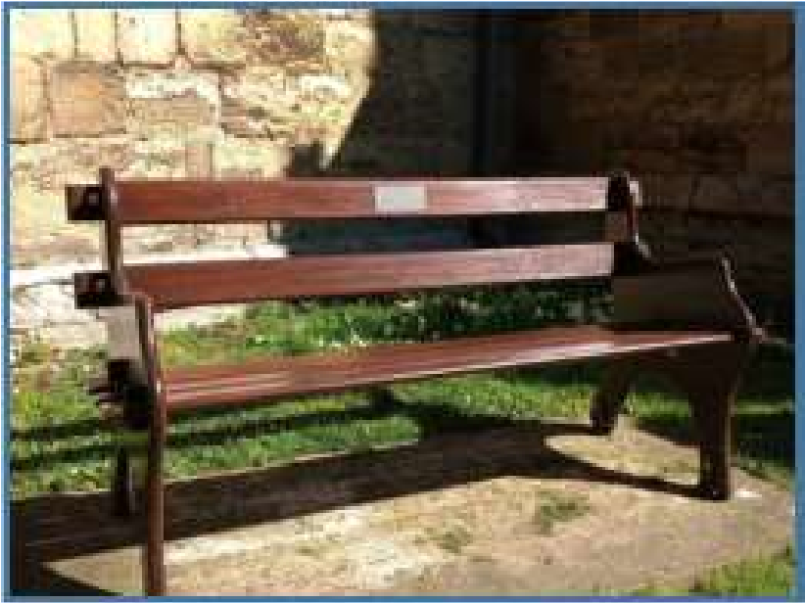
Jane

St Andrew
’
s Church

The PCC, we would like to say a big
‘
Thank You
’
to Chris Atkin for the
complete restoration of the bench in the church yard which had fallen into
decline over the years.

It was presented to Dr and Mrs P.E.G. Clements in November 1971 by
members of Middleton on the Wolds P.C.C. in appreciation of their many
years of loyal service to St Andrew
’
s Church. It is so nice to see it back in
use thanks to Chris.

We would also like to thank Chris for his help in repairing the church step
and his frequent support in maintaining the fabric of the church.

Lesley Kelly St Andrew
’
s PCC Secretary

Thank you

Advertising Feature

Advertisements
Advertisement
Advertising Feature
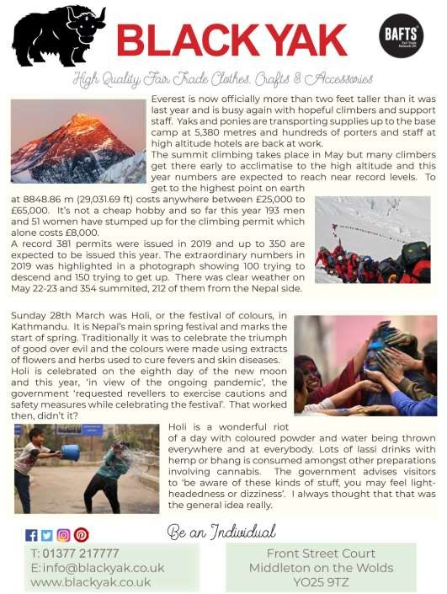
Regular group activities

Weekly Groups
Tuesday YCA 2.00-2.40pm Zoom
Thursday Middleton Movers 2.00-3.00pm Zoom

May
- Parish Council 7.00pm Zoom
- Village Hall Committee 2.30pm TBA
14 Book Group 2.00pm TBA
23 Middleton Womblers 10.00am Lime View 27 Yorkshire Countrywomen 7.00pm Zoom

LOCAL CONTACTS Bell Ringing Chris Atkin |  | 217285
Book Group/Middleton Movers | Lyn Dennis | 219500
Bowls Club | Rob Bradley | 217435
Country Women’s Association | Christine Johnson | 217374
First Responders | Chris Brent | 219469
Line Dancing | Pat Pottage | 217516
Methodist Chapel | Jane Gray | 07870 562455
Middleton Messenger | Mike Kelly | 07713 620912
 | Lyn Dennis | 219500
 | Tina Walker | 217242
Middleton Womblers | Andrew Naylor | 219072
Parish Clerk | Sandra Morrison | 01262 470496
Pilates | Ian Stephenson | 07973 755717
Reading Rooms | Kath Bentley | 217456
Recreation Club | Dave Newlove | 07901 833784
St Andrew’s Church | Rev Jane Anderson | 219471
St Andrew’s Church Warden | Roger Lowe | 217656
Table Tennis | Louise Newlove | 217801
Village Hall | Lyn Dennis | 219500
Village History | Geoff Wisher | 217517

